PARKING MANAGEMENT SYSTEM
ABSTRACT
The proposed project is a parking system that provides institutes user an easy way of reserving a parking space using portal. It overcomes the problem of finding a parking space in bike stand/organization areas that unnecessary consumes time. Hence, this project offers a system application where user can view various parking spaces and select nearby or specific area of their choice to view whether space is available or not. If the booking space is available, then user can book it for specific time slot. The booked space will be marked and will not be available for anyone else for the specified time. This system provides an additional feature of cancelling the bookings. User can cancel their reserved space anytime. User can also view previous parking booking details using the web portal.
This project can also help to manage paid parking facility where the amount of parking gets deducted automatically whenever the card is swiped and the available number of car parking are displayed. This project is very useful in this modern world, where space has become a very big problem and in the area of miniaturization it’s become a very crucial necessity to avoid the wastage of space in modern, big companies and apartments etc. In space where more than 200 cars need to be parked, it’s a very tough task to do and also to reduce the wastage of area, this system can be used. It saves our time and money This project provides a lot of features to manage in very well manner. This project contains a lot of advance modules which makes the back end system very powerful.

SYSTEM SPECIFICATION
HARDWARE SPECFICATION:
- Processor : P 4 700 GHz.
- RAM : 4 GB RAM
- Hard Disk Drive : 180 GB

SOFTWARE SPECIFICATION:

  - Operating System : Windows 7/8/10
  - Front End : JAVA
  - Back End : SQL

EXISTING SYSTEM
Now a days a carking system will be worked by manually. A customer waiting a long time then parking a car/bike. A worker has manually calculated the timings and amount. Sometimes it causes some issue for calculating the amount.
DISADVANTAGES:
- Customer waiting a long time for parking a vehicle.
- Calculate amount manually.
- Cause some issue
- Hard to manage
PROPOSED SYSTEM
In this system can be user parking their vehicle automatically. User book their slot and parking that place. So, the workers have won’t get confused for allocating a space or something. Which system has very useful to calculate time between the parking time.

ADVANTAGES:
- Calculate amount automatically based on parking time.
- No need to allocate search the free space.
- Time consumption is very low.
- Very easy to manage.

MODULES
- Customer Registration
This module is used to create customer by workers or manager. Every customer has registered in this module. We can see our customer details manually.
2. Generate Token
After customer parking their vehicle token number was automatically generated. Based on this token number we can calculate the amount. The amount was automatically calculate based on the total number of hours.
- Parking Slot Registration
This module will be creating slot for parking space. Before parking customer, the administrator will create the parking slot space. This is a kind of rule based on its parking area.
- IN/OUT Entry Registration
An IN/OUT entry registration module handle the in out time details, some peoples are managing this, this is a main module because used on this to we can collect the parking and generating the bill amount
- Billing Report
Billing report will be generated on every customer left. Administrator saw the income and outgoing billing report. We can saw the daily report also.

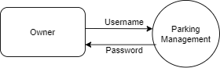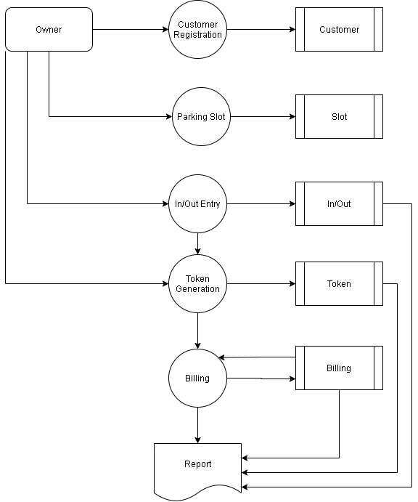
TABLE NAME : ADMIN
FIELD | DATA TYPE | SIZE | CONSTRAINT
admin id | Int | 10 | Primary key
Username | varchar | 30 | Not null
Password | Varchar | 30 | Not null

TABLE NAME : CUSTOMER
FIELD | DATA TYPE | SIZE | CONSTRAINT
Customer id | Int | 10 | Primary key
Name | Varchar | 30 | Not null
Mobile number | Int | 10 | Not null
Password | Varchar | 20 | Not null
Vehicle | Varchar | 20 | Not null
Rc number | Varchar | 20 | Not null
Address | Varchar | 30 | Not null

TABLE NAME : SLOT
FIELD | DATA TYPE | SIZE | CONSTRAINT
Slot id | Int | 10 | Primary key
Slot name | Varchar | 30 | Not null
total | Int | 5 | Not null

TABLE NAME: IN/OUT
FIELD | DATA TYPE | SIZE | CONSTRAINT
In/out id | Int | 10 | Primary key
Customer id | Int | 10 | Foreign key
Slot id | Int | 10 | Foreign key
In time | Date | 10 | Not null
Out time | Date | 10 | Not null

TABLE NAME: BILLING
FIELD | DATA TYPE | SIZE | CONSTRAINT
Bill id | Int | 10 | Primary key
Slot id | Int | 10 | Foreign key
Customer id | Int | 10 | Foreign key
Token number | Int | 5 | Not null
In time | Date | 10 | Not null
Out time | Date | 10 | Not null
amount | Int | 5 | Not null

